St. Augustine Parish

2486 West 14th Street
Cleveland, Ohio 44113

(216) 781-5530
(216) 781-1124 Fax
E-mail: staugch@earthlink.net
Website: StAugustineCleveland.org

First Sunday of Lent
February 21, 2021

Administrator

Rev. William O’Donnell, C.PP.S

Pastor Emeritus

Rev. Joseph D. McNulty

Parochial Vicar
Rev. Benjamin Jimenez, SJ

Permanent Deacons

Deacon John Rivera, Retired

Deacon David Mayer

Deacon Chris DePenti
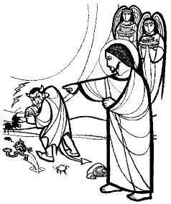

Pastoral Associates

Sr. Corita Ambro, CSJ

Retired Program Director

Bob Duda

Parish Life Coordinator and

Program Administrator-

Disability Ministries

Coordinator of Religious Education

Kathleen Ulintz

Director of Special Religious Education

Terry Hogan

Office Manager

Doris Everetts

Office Hours
During Pandemic

Monday thru Saturday: 9 AM to 5 PM
Sunday: 9 AM to 3 PM

Hunger Center Serving Hours
During Pandemic

10:30 AM to 12:30 PM
Mass Schedule

Weekday:
Monday - Friday: 5:30 PM

Weekend:
Saturday: 5:30 PM*
Sunday: 8:30 AM*, 10:20 AM*, and 12:30 PM
*Interpreted for the Deaf
A Samaritan Church with a Missionary Heart

First Sunday of Lent
Forty days from now we will find ourselves at the foot of the cross. How can we prepare ourselves for this? Jesus’ words at the beginning of his ministry are apt: “Repent, and believe in the gospel.” Let us ask ourselves how we have sinned. Let us feel remorse for those times we have fallen short. Let us resolve to turn back to God and live out the gospel in our day-to-day lives. Let us find ourselves able to approach the cross forty days from today with profound gratitude for what our Lord has done for us.
Mass Intentions
February 20th and 21st, 2021

February 20th – 5:30 PM †LuLu Gonzalez
Fr. Bill O’Donnell, C.PP.S
February 21st – 8:30 AM †Chappelle Letman
Fr. Ben Jimenez, SJ
February 21st – 10:20 AM †Claire Cocklin
Fr. Joe McNulty
February 21st - 12:30 PM †Emil Solderitsch and
Fr. Bill O’Donnell, C.PP.S Theresa Solderitsch

READINGS FOR THE WEEK OF
February 22, 2021
Monday: 1 Pt 5:1-4; Ps 23:1-6; Mt 16:13-19
Tuesday: Is 55:10-11; Ps 34:4-7, 16-19; Mt 6:7-15
Wednesday: Jon 3:1-10; Ps 51:3-4, 12-13, 18-19; Lk 11:29-32
Thursday: Est C:12, 14-16, 23-25; Ps 138:1-3, 7c-8; Mt 7:7-12
Friday: Ez 18:21-28; Ps 130:1-8; Mt 5:20-26
Saturday: Dt 26:16-19; Ps 119:1-2, 4-5, 7-8; Mt 5:43-48
Sunday: Gn 22:1-2, 9a, 10-13, 15-18; Ps 116:10, 15-19; Rom 8:31b-34; Mk 9:2-10

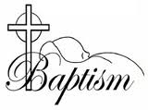
We welcome in Baptism, Aeza Colon. May the Light of Christ, given in Baptism, shine on Aeza forever. Amen!
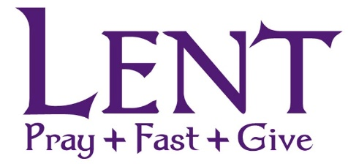

PARISH WIDE SURVEY
St. Augustine Parish will be participating in a parish-wide survey about discipleship conducted by the Catholic Leadership Institute, a non-profit Catholic apostolate that does leadership training and development. The Disciple Maker Index Survey for our Parish is currently open and we need your help!
Please help us participate by completing a 10-15 minute confidential survey as soon as possible:
- The easiest and most secure way to access the Disciple Maker Index Survey designed specifically for our parish is to visit our parish website: www.staugustinecleveland.org. There you will find a direct link to the DMI page and the survey will be accessed through a simple click on the established link. Complete the survey, click on submit and you have helped our parish with your input!

- You will also have the opportunity from that page to print a paper copy of the survey, which you can print, complete and return to the parish office or at the table located by the elevator in church. Complete the survey, return the paper copy and you have helped us with your input!

- Go to: https://portal.catholicleaders.org/dmi/survey/d8t6cdp9x7 directly from your home computer browser, follow the prompts to complete the survey, submit the results and you have helped us with your input!

- Obtain a paper copy on the table by the elevator in the church or at the parish rectory office by calling (216) 781-5530. Complete the survey, return the paper copy to the parish and you have helped with your input!

The survey will available until March 22, 2021 and will ask you to reflect on your own spiritual growth and enable you to provide feedback on our parish’s efforts to help you grow. All responses will be confidential, and the parish will only receive information about the community as whole. We are trying to get the highest response rate possible. This information will be invaluable to Fr. Bill and our various ministries as we plan for the future and strive to be the best disciples we can be. We will receive the results this spring/summer at which time we will share what we have learned with the entire parish. Thank you for helping with this important project!
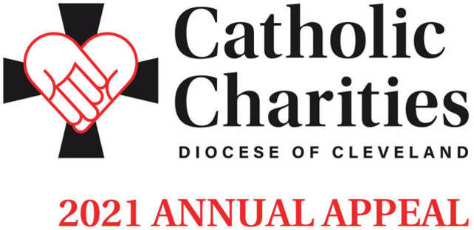
The 2021 Catholic Charities
Annual Appeal is underway with an in-pew commitment process taking place this weekend. This is not a special collection; rather, the Catholic Charities Annual Appeal represents the chance for all Catholics to make a significant pledge, payable in installments, to Catholic Charities, Diocese of Cleveland in order to support its mission of a society that stands united in its support of the “least among us.” Many parishioners have received a letter from Bishop Malesic requesting their support. If you have not received this letter, please respond to the in-pew commitment process today! If you have received the mailing, please respond to it. There is a box on the in-pew envelope to indicate that you have responded by mail. Double your impact! A generous donor, who believes in the mission of Catholic Charities, will match your gift, up to $1 million. Do twice as much good when you give online at CatholicCommunity.org/Match. On behalf of the poor and needy of Northeast Ohio, thank you!

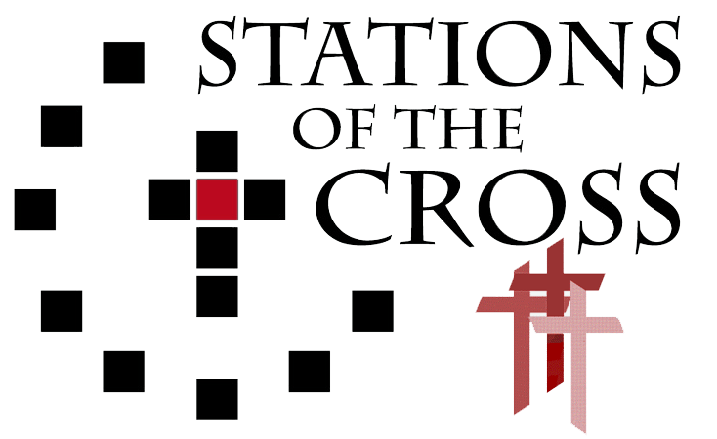
Fr. Joe McNulty will lead us in our annual Stations of the Cross meditation each Friday during Lent. Please note that this year our Stations will begin at 5:30 PM followed by daily mass.

The Little Black Books
Spend six minutes a day preparing for the most holy season of the year. These pocket-sized booklets contain reflections for each of the days in Lent and were provided through the generosity of a donor. The Little Black Books are available for your taking at the Church entrances.

Joint Councils Meeting
Due to the inclement weather last week the joint Councils meeting was postponed until Monday, March 15th . The meeting will be held at 7 PM in the Deaf Center.
Prayer Request
(216) 781-5530 ext. 24
We would be honored to include your needs in our daily prayers. You may leave a prayer request by contacting our 24-hour prayer line or on the parish website.
Fish Fry
Due to the pandemic, the diocese discourages parishes from offering a dine-in fish fry. After much thought, discussion, and deep regret, we have decided to not have our fish fry this year. We are hopeful that our Fish Fry will return in 2022.

Hunger Center Calendar
The 2021 Hunger Center Calendar is still available for purchase in the Parish Office. The cost per calendar is $25 each and gives each buyer a chance to win money 362 times out of the year. Thank you for your continued support.

Weekday Mass Schedule
As we enter Lent, a season of penance and turning back to the Lord. It is a time that we prepare to celebrate the central mysteries of our faith in Holy Week and Easter. We traditionally think about it as a time to “give up” something. The Church doesn’t call us to “give up” something officially though, but instead to “take up” some new things. These are the practices of PRAYER, FASTING and ALMSGIVING.
“The key to fruitful observance of these practices is to recognize their link to baptismal renewal. We are called not just to abstain from sin during Lent, but to true conversion of our hearts and minds as followers of Christ. We recall those waters in which we were baptized into Christ's death, died to sin and evil, and began new life in Christ.” - United States Conference of Catholic Bishops
To help with these Lenten practices, we have changed our weekday Mass schedule. Our weekday Mass will be celebrated at 5:30 PM Monday thru Friday.

Easter Meals
We have begun taking meal orders for delivery on Easter. These orders can be placed by calling the parish office, or by filling out an online order request on the parish website.

At this time volunteers are still asked to call or email the parish office for more information or to sign up

St. Augustine Signing Choir
The St. Augustine Signing Choir will be continuing their weekly practice this Wednesday, February 24th in Walsh Hall. New members are welcome! Practice for individuals learning sign language will begin at 6:30 PM. Those with basic sign knowledge are invited to join the practice at 7 PM. For more information please contact Bob Duda by calling the parish office or at rwduda@ccdocle.org.
Parish School of Religion (PSR)/CCD
Parish School of Religion/CCD will continue on Monday, February 22, 2021 with in person and virtual options available. If you have not registered your child(ren) please do so by either calling the parish office or emailing Kathleen Ulintz at Staugustinepsr@yahoo.com.

Hunger Center Calendar
The 2021 Hunger Center Calendar is still available for purchase in the Parish Office. The cost per calendar is $25 each and gives each buyer a chance to win money 362 times out of the year. Thank you for your continued support.

Ultreya
The next Ultreya gathering will be on Saturday, March 13th at 10 AM in Walsh Hall. Cursillistas are invited to gather, pray, and share personal stories about living a life in God's Grace on the second Saturday of every month.

Calendar Winners

February 15, 2021 David Frank #21105
February 16, 2021 Denise Kovijanich #21170
February 17, 2021 Jeff Keeper #21058
February 18, 2021 Bryan O’Malley #21190
February 19, 2021 Daniel Helsel #21187
February 20, 2021 Anna Vucica #21017
February 21, 2021 Annie Dixon #21207

Inspiration for the Week
Throughout history God has given His people signs. Our season of Lent offers us God’s sign that it is time to stop the ordinary routines of our lives, create some desert space, and listen more attentively for God to reveal His presence. We are asked to unplug from our attachments, compulsions, obsessions, addictions, routines, and busyness to clear the slate and take stock in who we have become. We are asked to remember the ancient sign of God’s covenant with humanity in which He vowed to nurture, sustain, and protect the relationship He has with His people. Once we slow down a bit and clear away some of the clutter, we can see how the journey of our life is unfolding. We can see what brings us in and out of tune with God’s love and how we can better imitate God’s loving fidelity in our relations with Him. Even though some good solid self-denial is the order of the day, greater happiness and wholeness will be the fruit of our labors. Pleasant journey through the desert!
Stewardship of Treasure
We are deeply grateful for your generosity in your weekly contribution to St. Augustine Parish. Your kindness and support enable us to provide for the needs of our parish and community. The collection for the weekend of February 14, 2021 was $1,891.00. Thank You!
Weekend of February 20th and 21st
 | Saturday  5:30 PM | Sunday  8:30 AM | Sunday  10:20 AM | Sunday  12:30 PM
Priest  Deacon | Fr. Ben Jimenez (H)  Deacon Dave Mayer | Fr. Ben Jimenez (H)  Deacon Dave Mayer | Fr. Bill O’Donnell (H)  Deacon Chris DePenti | Fr. Bill O’Donnell (H)  Deacon Chris DePenti
Lectors | Mary Step | Bob Duda | Colleen Cassidy  John Kowalchik | Priscilla Treska
Extraordinary Ministers of
the Blessed Sacrament
Weekend of February 27th and 28th
H:Homilist
Livestream
Livestreamed Masses can be simultaneously viewed on our parish website (www.staugustinecleveland.org), on our Facebook Page (St. Augustine Roman Catholic Church Cleveland) and on our YouTube Channel (St. Augustine Church)
Our streams can be viewed live on Saturday at the 5:30 PM or on Sunday at the 10:20 AM Mass. All recordings can be viewed at a later time on all three platforms.
In addition, live audio feed will be available for the Saturday 5:30 PM Mass and the 10:20 AM Sunday Mass. To access the audio feed, please call (216) 270-6331 prior to mass and enter the code 2020 when prompted.

Family Perspective
Jesus went into the desert to put his life in perspective. This lent, take a fresh look at a difficult relationship in your life. Concentrate on the positive things that person does, not just the negatives. Try to understand why their behaviors ‘bug’ you. Can you honestly share your feelings with them without attacking them? Make Lent a time to mend and forgive!
Observances for the Week
Feb 22 Feast of the Chair of St. Peter the Apostle
Julian Calendar Lent Begins
Feb 23 Optional Memorial of St. Polycarp
On the Lighter Side
"Somebody has said there are only two kinds of people in the world. There are those who wake up in the morning and say, "Good morning, Lord," and there are those who wake up in the morning and say, "Good Lord, it's morning."

 | Saturday  5:30 PM | Sunday  8:30 AM | Sunday  10:20 AM | Sunday  12:30 PM
Priest  Deacon | Fr. Bill O’Donnell (H)  Deacon Chris DePenti | Fr. Ben Jimenez (H)  Deacon Chris DePenti | Fr. Joe McNulty (H)  Deacon Dave Mayer | Fr. Bill O’Donnell (H)  Deacon Dave Mayer
Lectors | Migdalia White | Peggy Gerovac | Karen Halupnik  Alana Ortiz | Aaron Calton
Extraordinary Ministers of  the Blessed Sacrament |  |  | Bob Cassidy  Molly Cassidy | Latoya Montanez

