St. Augustine Parish

2486 West 14th Street
Cleveland, Ohio 44113

(216) 781-5530
(216) 781-1124 Fax
E-mail: staugch@earthlink.net
Website: StAugustineCleveland.org

Third Sunday of Advent
December 13, 2020

Pastor

Rev. Joseph D. McNulty

Parochial Vicar
Rev. Benjamin Jimenez, SJ

Permanent Deacons

Deacon John Rivera

Deacon David Mayer

Deacon Chris DePenti

Pastoral Associates

Sr. Corita Ambro, CSJ

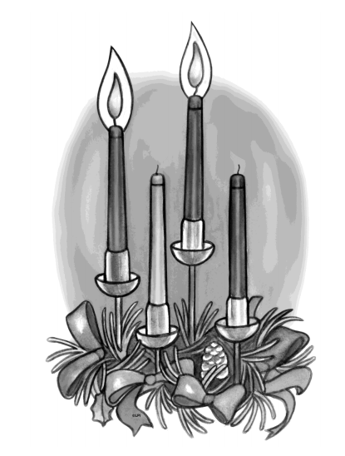
Retired Program Director

Bob Duda

Program Administrator-

Disability Ministries

Mary Smith

Disability Advocate

Coordinator of Religious Education

Kathleen Ulintz

Director of Special Religious Education

Terry Hogan

Office Manager

Doris Everetts

Asst. Office Mgr.

Winnie Mack

Mass Schedule

Weekday:
Mondays and Fridays: 5:30 PM
Tuesday, Wednesday, and Thursday: 11 AM

Weekend:
Saturday: 5:30 PM
Sunday: 8:30 AM, 10:20 AM, and 12:30 PM

P
E
A
C
E

HOPE

JOY

L
O
V
E

Office Hours
During Pandemic

Monday thru Saturday: 9 AM to 5 PM
Sunday: 9 AM to 3 PM

Hunger Center Serving Hours
During Pandemic

11 AM to 12:30 PM

Third Sunday of Advent

The Third Sunday of Advent is called Gaudete Sunday because today’s opening antiphon begins with the word gaudete, which means rejoice. We rejoice today, for the coming of the Lord is so near that we cannot help but think about it. Perhaps we are starting to feel overwhelmed by all of what we need to do between now and Christmas. Let this be an opportunity to refocus our attention on the true reason we celebrate this time of year. Rejoice, the Lord is near!

Mass Intentions
December 12th and 13th, 2020

December 12th – 5:30 PM †Leo and Dorothy Bender
Fr. James Shea, SJ
December 13th – 8:30 AM †June Parschen
Fr. Tom Mahoney
December 13th – 11 AM †Claire Jane Cocklin
Bishop Edward Malesic
READINGS FOR THE WEEK OF
December 14, 2020
Monday: Nm 24:2-7, 15-17a; Ps 24:4-5ab, 6, 7bc, 8-9; Mt 21:23-27
Tuesday: Zep 3:1-2, 9-13; Ps 34:2-3, 6-7, 17-18, 19, 23: Mt 21:28-32
Wednesday: Is 45:6b-8, 18, 21c-25; Ps85:9ab, 10-14; Lk 7:18b-23
Thursday: Gn 49:2, 8-10; Ps 72:3-4, 7-8, 17; Mt 1:1-17
Friday: Jer 23:5-8; Ps 72:1-2, 12-13, 18-19: Mt 1:18-25
Saturday: Jgs 13:2-7, 24-25a; Ps 71:3-4a, 5-6b, 16-17; Lk 1:5-25
Sunday: Sm 7:1-5, 8b-12, 14a, 16; Ps 89:2-5, 27, 29; Rom 16:25-27; Lk 1:26-38

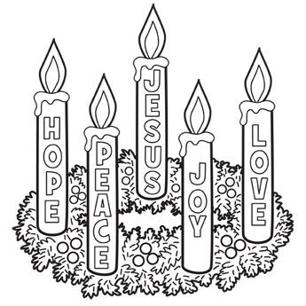

Advent Reflections
As we prepare our hearts and home for the coming of Christ, we invite you to journey with us. Each week, Deacon Chris will offer a weekly Advent reflection. Deacon Chris’ weekly reflections will be uploaded to our parish website, Facebook page, and YouTube.
Important Reminders
The dispensation from the obligation to attend Sunday Mass remains in effect. If you are of compromised health, not feeling well or exhibiting any symptoms, please stay home.
If you decide to attend Mass, please keep in mind:
▪Take your temperature just prior to coming to Mass- if above 100.4 please stay home.
▪Follow all social distancing requirements when entering the church.
▪Sit in designated pews only. Families who live together may sit together, but please maintain social distancing from other families and individuals in attendance.
▪If you use the Missalette please be sure to take the book home with you and bring it back each week.
▪Please take the bulletin home with you when you leave-do not leave it in the pew.
▪Please place your offering envelopes in the stationary boxes located by the elevator and by the ramp, no collection will take place.
▪During the distribution of Holy Communion please stay in your pew/seat.
▪Please exit the church at the conclusion of Mass to allow for sanitation.
Thank you for your presence and cooperation as we strive to keep you safe during this time.
Welcome, Bishop Malesic!
This Sunday we welcome Bishop Edward Malesic to our parish. Bishop Malesic was installed the 12th Bishop of the Diocese of Cleveland this past September. We are honored that he will be the celebrant and homilist at a combined 11 AM Mass this Sunday.
Bishop Malesic’s motto is, “Serve the Lord with Gladness.” May we continue to imitate his motto and serve the Lord with gladness in all that we do.
Due to the pandemic there will not be a reception following the liturgy.

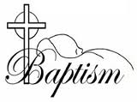

Called by Name to be A Child of God

Carter Smith

Jaxson Smith
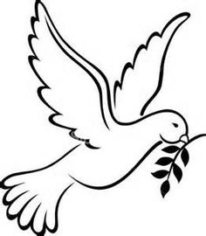

Eternal Rest Grant unto them, O Lord

Robert Fleck

Melinda Sammon

Religious Retirement Fund

In good times and bad, senior Catholic sisters, brothers and religious order priests have dedicated themselves to service and acts of mercy. Today they pray for an aching world. Yet years of serving for little or no pay have left their religious communities without enough retirement savings. Your gift to the Retirement Fund for Religious helps provide medications, nursing care and other necessities. There will be a special collection this weekend, December 12th and 13th, to help these very dedicated senior religious sisters, brothers and priests who have done so much for our Catholic schools, missions and parishes.
Parish School of Religion (PSR)/CCD

Parish School of Religion/CCD will continue on Monday, December 14th with in person and virtual options available. If you have not registered your child(ren) please do so by either calling the parish office, emailing Kathleen Ulintz at Staugustinepsr@yahoo.com or by completing a form on the parish website.

On the Lighter Side
A little boy had just finished off all the cookies In the kitchen. His mother came in and, seeing the empty cookie jar and the crumbs, said to the wee lad, "Son, who ate all the cookies?" The little boy replied, "An animal did." What kind of animal?" his mother asked. The young boy was thoughtful for a moment, then he smiled: "One of Jesus' little lambs."
Thank You!

On behalf of Catholic Charities Disability Ministries and the Cleveland Catholic Deaf Center thank you for supporting us this past Tuesday during our #WeGiveCatholic campaign. We raised $1,070.00 for our deaf retreat programs for 2021.
Stewardship of Treasure

We are deeply grateful for your generosity in your weekly contribution to St. Augustine Parish. Your kindness and support enable us to provide for the needs of our parish and community. The collection for the weekend of December 6, 2020 was $1,793.90. Thank You!
Prayer Request
(216) 781-5530 ext. 24
We would be honored to include your needs in our daily prayers. You may leave a prayer request by contacting our 24-hour prayer line or on the parish website.
Hunger Center Calendar
We are excited to announce that the 2021 calendar is in. The cost per calendar is $25 each and gives each buyer a chance to win money 362 times out of the year. The calendar makes a perfect gift for yourself or someone you know. Thank you for your continued support. Calendars are available in the parish office.

Theology on the Rocks
For Adults 40 and Over
THIS Monday, Dec. 14th at 7:00pm (Via Zoom)
Presenter: Fr. Mark Hollis, retired Spiritual Director
Topic: Intercessory Prayer & the Role of the Saints

At baptism we are christened, named after a saint, and when we are troubled, we pray to our patron saint to intercede on our behalf. Join us as Fr. Mark Hollis will dive a little deeper into the prayer connection we have with all the saints and their role in our relationship with God. Register in advance as space is limited for this virtual (Zoom) event. www.theologyontherocks.wixsite.com/west
Livestream
Livestreamed Masses can be simultaneously viewed on our parish website, www.staugustinecleveland.org, on our Facebook Page (St. Augustine Roman Catholic Church Cleveland) and on our YouTube Channel (St. Augustine Church)
Our streams can be viewed live on Saturday at the 5:30 PM or on Sunday at the 10:20 AM Mass. All recordings can be viewed at a later time on all three platforms.
In addition, live audio feed will be available for the Saturday 5:30 PM Mass and the 10:20 AM Sunday Mass. To access the audio feed, please call (216) 270-6331 prior to mass and enter the code 2020 when prompted.

Prayer Request

(216) 781-5530 ext. 24
We would be honored to include your needs in our daily prayers. You may leave a prayer request by contacting our 24-hour prayer line or on the parish website.
Calendar Winners

December 7, 2020 Billy Gantt #20123
December 8, 2020 Diana Marvar #20218
December 9, 2020 Mary Lou Balchak #20206
December 10, 2020 Dorothy Grys #20495
December 11 , 2020 Toni Oden #20492
December 12, 2020 Fr. John McNulty #20101
December 13, 2020 Ausra Kaminskas #20099
An Advent Prayer
May the grace of the Advent season consume my heart
as I prepare for the coming of the Lord.
Let me not, especially this year,
overlook the hope and joy
which comes from fully embracing
the traditions of a Catholic celebration
of Advent and Christmas.

Question of the Week
When and where do I recognize the presence of the Lord in the world?

Sunday Thought
The Third Sunday of Advent is traditionally called “Gaudete” Sunday. The Latin word is translated “Rejoice” and was the first word from the entrance antiphon for the Mass. In our first reading from the Prophet Isaiah, this call to rejoice is applied to Jesus in prophecy. Jesus truly was the one sent by God to bring the oppressed the good news of salvation, to heal those whose hearts are broken, to free captives and to release those held bound by any form of imprisonment. Yet this should not be the only source of joy for us today. Whatever we apply to Jesus, we must apply also to ourselves since today we are the Body of Christ in the world. We, the followers of the Lord Jesus, as unworthy as we might be, possess the same outpouring of the Spirit as He did as well. Jesus sends us to care for the broken hearted. He sends us to liberate captives and release prisoners. There is no need to look everywhere for any of these men and women we are called to assist. They are in our own homes. They are our neighbors and friends. You will find them in the hospital and nursing home. They are all around us for anyone who can use our help. It is to these we have been sent.
Family perspective
Today’s gospel reports “I am the voice of the one crying out in the desert.” Who in your family is crying out with their crazy schedules, suppers that start too late and end too early, cars that don’t start, misunderstandings, piles of laundry, unmatched socks and stretched food budgets? Although the list feels endless, there is one who hears you. The words spoken at mass, “The Lord is with you,” are not just a hope, they are a fact .

Observances for the Week
Dec 14 Memorial of St. John of the Cross
Dec 18 Hanukkah Ends
Weekend of December 12th and 13th
 | Saturday  5:30 PM | Sunday  8:30 AM | Sunday  11:00 AM
Priest | Fr. Jim Shea, SJ | Fr. Tom Mahoney | Most Reverend Edward Malesic  Bishop of Cleveland
Lectors | Dave Dylyn | Ed Zubek | Jeannie Rawlings  Matt Rawlings
Extraordinary Ministers of  the Blessed Sacrament | Theresa Yurchisin | Bob Duda
Weekend of December 19th and 20th
 | Saturday  5:30 PM | Sunday  8:30 AM | Sunday  10:20 AM | Sunday  12:30 PM
Priest | Fr. Joe McNulty | TBD | Fr. Ben Jimenez, SJ | Fr. Joe McNulty
Lectors | Dave Dylyn | Sandy Bernardo | Karen Halupnik  Alana Ortiz | Terry Hogan
Extraordinary Ministers of  the Blessed Sacrament | Theresa Yurchisin | Frank Kilbane | Chuck Adkins | Aaron Calton
Inspiration for the Week
What gives you joy? Joy is discovered when we connect with something or someone very deeply and experience a dimension of ourselves that material or secular possessions cannot bring. Joy is stumbled upon when we see our newly born child for the first time, get caught up in the vastness of a mountain landscape, and are led out into infinity gazing at an ocean’s horizon, or being lovingly present with someone when they are vulnerable and in need. Joy is a profound experience that in its uniqueness grounds us in ultimate truth. Did you know that all authentic, profound, and memorable moments of joy mirror the eternal joy we desire from God? We can have glimpses of this eternal Diving joy as we embark upon our earthly journey, mirrored in our human connections with joy, but experienced directly during moments of deep prayer. God is the joy of my soul. Ponder those intense words! You will know moments of true and real joy by paying attention to your response to the experience. You will find yourself rejoicing and saying thank you.

