St. Augustine Parish

A Samaritan Church with a Missionary Heart

2486 West 14th Street
Cleveland, Ohio 44113

(216) 781-5530
(216) 781-1124 Fax
E-mail: staugch@earthlink.net
Website: StAugustineCleveland.org

Our Lord Jesus Christ, King of the Universe
November 21, 2021

Administrator

Rev. William O’Donnell, C.PP.S

Pastor Emeritus

Rev. Joseph D. McNulty

Parochial Vicar
Rev. Benjamin Jimenez, SJ

Permanent Deacons

Deacon Chris DePenti

Pastoral Associate

Bob Duda

Parish Administrator and

Program Administrator-

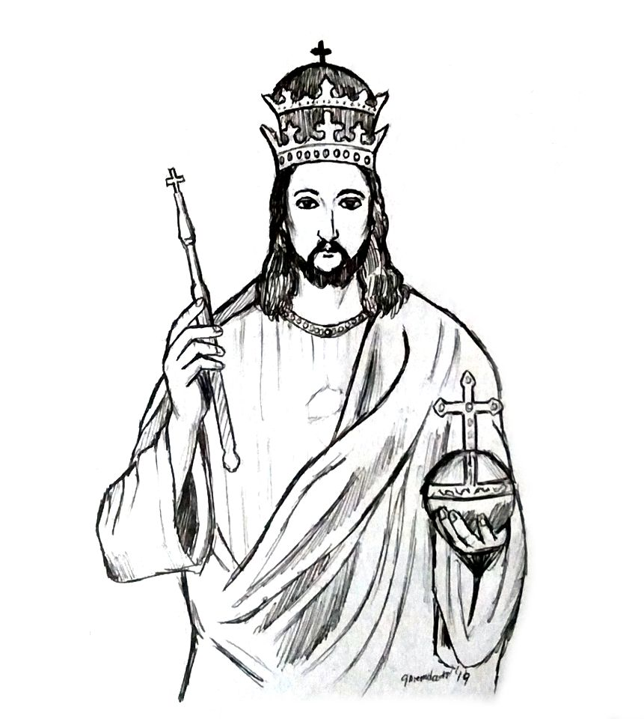
Disability Ministries

Coordinator of Religious Education

Kathleen Ulintz

Coordinator of Special Religious Education

Terry Hogan

Office Manager

Doris Everetts

Mass Schedule
Weekday:
Monday thru Friday: 5:30 PM
(Civic holidays at 10 AM)

Weekend:
Saturday: 4:15 PM*
Sunday: 8:30 AM* and 11 AM*
*Interpreted for the Deaf
Office Hours
Monday thru Friday: 9 AM to 5 PM
Saturday: 9 AM to 4 PM
Sunday: 9 AM to 2 PM

Confession
Saturday: 3:30-4 PM or by appointment

Parish Registration – Welcome new members! Please register by calling the parish office. Parishioners who are moving are asked to contact the office to update their information  Baptism – Baptisms may be scheduled at any time. Please call the parish office to make baptismal arrangements. | Funerals – Please call the parish office to schedule funerals prior to publishing any information.  Matrimony – Call the parish office to meet with a priest. Diocesan regulations require a minimum of 6 months preparation time. | Care of the Sick – Notify the parish office of those who are hospitalized or homebound. Arrangements can be made for pastoral visits, the Sacrament of the Anointing or the Sick. We can also bring Holy Communion to the homebound.

Solemnity of Our Lord Jesus Christ,
King of the Universe
Today we recognize Jesus’ role as the Lord of all, the ruler over all humanity, the king of the eternal heavenly kingdom. To his followers, Jesus referred to this kingdom as the kingdom of God or his Father’s kingdom, but through his ultimate act of self-sacrifice he became the firstborn of this kingdom, ready to show us the way. Let us pray that when our day comes, we will be found worthy and ready for the kingdom.
Mass Intentions for the Week

Saturday, Nov. 20th- 4:15 PM † Bob Bencic
Fr. Ben Jimenez, SJ
Sunday, Nov. 21st - 8:30 AM † Tony Gelzinis
Fr. Joe McNulty
Sunday, Nov. 21st - 11 AM † Leonard Whigham
Fr. Bill O’Donnell, C.PP.S
Monday, Nov. 22nd- 5:30 PM † Margaret Connelly St. Cecilia, Martyr
Tuesday, Nov. 23rd- 5:30 PM † Robin Zarembski St. Clement I, Pope and Martyr
St. Columban, Abbot
Bl. Miguel Agustín Pro, Priest and Martyr
Wednesday, Nov. 24th- 5:30 PM † Loretta Dulik St. Andrew Dung-Lac & Companions, Martyrs
Thursday, Nov. 25th- No Mass St. Catherine of Alexandria, Martyr
Friday, Nov. 26th No Mass
Saturday, Nov. 27th- 4:15 PM † Gertrude and
Fr. Bill O’Donnell, C.PP.S Henry Senyak
Sunday, Nov. 28th - 8:30 AM † Frank Iskra
Fr. Ben Jimenez, SJ
Sunday, Nov. 28th – 11 AM † Sr. Wilma Apack
Fr. Joe McNulty (Sr. Ann Joseph)

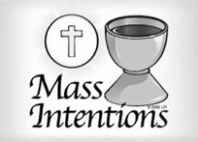
2022 MASS BOOK
The 2022 Mass Book is now available for Parishioners requesting Mass Intentions for the year 2022. Mass request can be made by calling the parish office, by mail, or by placing your request in the collection box. Please include your name, address, and phone number on the request along with your intention, so that we can contact you if any adjustments are necessary.

READINGS FOR THE WEEK
Monday: Dn 1:1-6, 8-20; Dn 3:52, 53, 54, 55, 56; Lk 21:1-4
Tuesday: Dn 2:31-45; Dn 3:57, 58, 59, 60, 61; Lk 21:5-11
Wednesday: Dn 5:1-6, 13-14, 16-17, 23-28; Dn 3:62, 63, 64, 65, 66, 67; Lk 21:12-19
Thursday: Dn 6:12-28; Dn 3:68, 69, 70, 71, 72, 73, 74; Lk 21:20-28
Thanksgiving Day, Suggested: Sir 50:22-24; Ps 145:2-3, 4-5, 6-7, 8-9, 10-11; 1 Cor 1:3-9; Lk 17:11-19
Friday: Dn 7:2-14; Dn 3:75, 76, 77, 78, 79, 80, 81; Lk 21:29-33
Saturday: : Dn 7:15-27; Dn 3:82, 83, 84, 85, 86, 87; Lk 21:34-36
Sunday: Jer 33:14-16; Ps 25:4-5, 8-9, 10, 14; 1 Thes 3:12 — 4:2; Lk 21:25-28, 34-36

Welcome!
No matter what your present status in the Catholic Church, no matter your personal history, age, income, background, gender, sexual orientation, race, ethnicity or spirituality, or marital situation. No matter your own self-image of holiness or virtue. You are invited, accepted, and respected here at St. Augustine Parish.

Loving God,
For all who feel on the margins,
but who are at the center of your heart,
we ask you to open our hearts.
Help us to become a church and a nation where:
All lives have dignity,
All people are loved
And all are welcome.
Amen
Love without Measure…

Campaign for Human Development
Give someone a fish and feed him or her for a day;
Teach them to fish and feed them for a lifetime.

For over 50 years, the Catholic Campaign for Human Development has worked on the margins to break the cycle of poverty. It supports community and economic development efforts for poverty reduction by funding groups that defend workers’ rights, promote responsible environmental practices, advocate for people with disabilities and immigrants, and support employee- owned businesses. On November 20-21 the Cleveland Diocese along with the entire Catholic Church in the United States will take up the collection to support the Campaign for Human Development. When we take part in this collection, we support poverty reduction nationwide and in our own community. Twenty-five per cent of our contribution stays in the Cleveland Diocese to help local antipoverty initiatives.

The Feast of Christ the King
The Church year begins as the Church year ends, first, foremost, and always focused on Jesus Christ. It is in Christ who in his life, death, and resurrection we find our true and lasting hope. The Church exists for one reason, to make Jesus known and loved as we serve our neighbor especially those most in need.

Thanksgiving
In the name of Bob Duda, Father Ben, the entire parish staff, and myself I wish our entire parish family the blessing and joy that will be ours as we join together for the celebration of the Thanksgiving Season. This holy season makes us mindful of the importance of family and hopefully it will make us more aware of those who are alone and in need of not only food but also friendship.

Advent
The Season of Advent begins the new church year. It makes us very aware of how much waiting is part of human life and the Christian experience. Samuel Beckett is the author of a play that captures the spirit of this Holy Season. It is called Waiting for Godot. Two friends (homeless men) are waiting for the arrival of their friend Godot. But the play begins as they wait for Godot’s arrival and ends as the two men continue to wait with the haunting fear that Godot will never arrive, and their waiting will seem a terrible waste. In this play Beckett is challenging the Faith Community to ask what or who they are waiting for and is their faith in the arrival of the

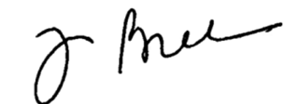
Lord trustworthy or not. Advent is about Emmanuel, God with us, in Jesus Christ and his return at the end of time. Did you know that the final words found in the New Testament, the Book of Revelation is “Come Lord Jesus!” And so, in faith we live out our faith as we build the Kingdom of God among us, trusting in the Lord’s Risen Presence among us in the Holy Spirit and waiting for Christ’s coming at the end of time.

Eternal Rest Grant unto her, O Lord
JoAnn Krajnak
a longtime member of our Deaf Community

Parish Breakfast THIS Sunday

Welcome! You’re invited to a complimentary parish breakfast this Sunday, November 21st from 9:00 AM to 1 PM in Walsh Hall (basement of school building).

We hope that you will be able to join us for food and fellowship. This is a great opportunity to see longtime friends and meet new members of our parish family.

The Parish Breakfast will be a monthly event that will occur on the 3rd Sunday of most months. Please be sure to save the date for future breakfasts.

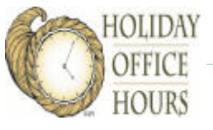
The Parish Office will CLOSE at: 5:00P.M. on Tuesday, Nov. 23rd and remain closed until Saturday, November 27th at 9:00 A.M

Mass of Thanksgiving
Bishop Roger Gries, OSB will be celebrating a Mass of Thanksgiving on Wednesday, November 24th at 5:30 PM. We hope that you will join us in giving thanks for the many blessings we have in our life. We will not have a Mass on Thanksgiving Day.
Christmas Cards for the Military
On behalf of Helen Bencic and the many men and women protecting our freedoms in the Armed Forces, thank you for taking the time to sign and personalize Christmas Cards that will be mailed with care packages to our service men and women away from home this holiday season.

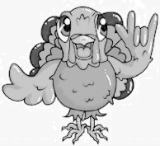
Thank You!
Thank you to all who supported the Cleveland Catholic Deaf Center last Sunday at their annual Thanksgiving Dinner. A special thanks to all who helped plan, cook, and serve.
The Faithful Departed
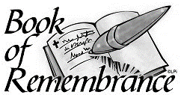
During the month of November, the Church takes special care to remember the souls of the Faithful Departed. A Book of Remembrance will be placed in the front of the church by the ramp for you to enter the names of your deceased relatives and friends you wish to be prayed for during this month.

Parish Dance
Saturday, November 27th we will host an “Under the Stars” dance in Walsh Hall. The dance will be from 5 PM until 9 PM. DJ BobbyK will provide entrainment as we gather for an evening of fellowship and dancing. Tickets supporting the parish will be $15 and available after Mass.
Pro Orantibus Day
This Sunday, November 21, 2021 is “Pro Orantibus Day” (For those Who Pray), honoring cloistered men and women. It is day of thanksgiving, solidarity and support for contemplative religious who spend their lives in total dedication to God in union with Jesus and interceding for the salvation of all.

Pope Pius XII instituted this worldwide event in 1953 and Pope St. John Paul II expanded its celebration in 1997 to take place on the Memorial of Our Lady’s Presentation in the Temple. For more information on how you can participate in this celebration visit www.cloisteredlife.com.
In our diocese we have three religious communities of cloistered religious women to whom you may send a note of thankfulness for their ministry of prayer for us.
Carmel of the Holy Family
https://ccacarmels.org/cleveland-carmelites
2541 Arlington Rd., Cleveland Heights 44118
Poor Clare Colettines
www.pcc-cle.org
3501 Rocky River Dr., Cleveland 44111
Poor Clares of Perpetual Adoration www.thepoorclares.com
4108 Euclid Ave., Cleveland 44103
Sign Language Class
This past Tuesday officially ended our fall Sign Language Course. If you were unable to attend our fall session, please know that we will be offering another session right after the holidays.

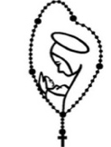
Pray the Rosary
We invite you to join us every weeknight (Monday thru Friday) at 7 PM in the church as we recite the rosary. If you are unable to join us in person, we encourage you to join us on livestream. Due to the Thanksgiving holiday, we will not have a live rosary on Wednesday, Thursday, or Friday of this week. Beginning Monday, November 29th, our Rosary will immediately follow the 5:30 PM weekday Mass at 6 PM.

St. Augustine Seniors
Will gather on, Thursday, December 9th at 12 Noon in Walsh Hall for their annual Christmas celebration. We encourage the use of masks while not seated. Thank you for your understanding.
Parish School of Religion (PSR)/CCD
This Monday there are no PSR classes due to the Thanksgiving Holiday. Classes will resume on Monday, November 29th at 5:30 PM. If you have not registered your child(ren) for the 2021-2022 school year, please do so by either calling the parish office, emailing Kathleen Ulintz at Staugustinepsr@yahoo.com.
Stewardship of Treasure
We are deeply grateful for your generosity in your weekly contribution to St. Augustine Parish. Your kindness and support enable us to provide for the needs of our parish and community. The collection for the weekend of November 14, 2021 was $4,362.73.00. Thank You.
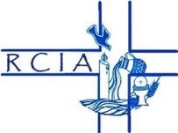
RCIA
Our RCIA (Rite of Christian Initiation of Adults) program will begin again in September and runs through May, with our celebration of Initiation at the Easter Vigil Mass. The RCIA is a process, not a program. It is designed for adults wishing to learn more about the Catholic faith. If you or someone you know desires to become a fully initiated Catholic, receiving the sacraments of Baptism, First Communion and Confirmation, please join us on Wednesday, December 1st from 7:00 PM to 8:00 PM in the rectory or contact the parish office at (216) 781-5530 for further information.
Sunday Thought
We have come to the end of another Liturgical Year and as we do so each year, we celebrate the Feast of Jesus Christ the King. Jesus avoided the title of “king” throughout His public ministry. He commanded the demons to hold their tongue about His true identity and He told His disciples to keep concealed their growing understanding of His royal nature. Now as the end of His life approaches and the true nature of His kingly reign will be seen as it truly is- a loving until death willing servanthood- there will be no room for any misconceptions. Jesus fits none of our conceptions of majesty and royal rule. Throughout the ages, monarchs have come and gone, despots and dictators alike. Yet none was as powerful as Jesus was to capture the hearts of their subjects. Never was there any other ruler who humbled himself unto death to save even His disloyal subjects, let alone those who proved themselves loyal. Just as Jesus’ love is absolute, so also is His claim upon us. He is our King, but we must decide to enthrone Him over our lives.
Family Perspective
Today’s gospel is clear that “everyone who belongs to the truth listens to my voice.” Truth is critical to fulfillment and happiness. Without it, we live suspiciously in a world of lies. What is the truth about the effect of our actions on children? A parent’s presence in the development of a child? The result of long workdays and too little time with families? Live the Gospel truth! Pray that families might pause this Thanksgiving to recognize God’s presence in their lives in the blessings and the sufferings, in the celebrations and in the sorrow.
Catholic Campaign for Human Development
This weekend is the annual special collection for the Catholic Campaign for Human Development. More than thirty-eight million people (1 in 8) in the United States live in poverty. The monies from the CCHD collection support programs that empower people to identify and address the obstacles they face as they work to bring permanent and positive change to their communities. Your donation also supports programs that address the root causes of poverty and provides a sustainable future for those struggling in poverty. In addition, 25% of your donations remain in our diocese to fund antipoverty projects. Please use the envelope provided in the bulletin. For more information go to: usccb.org/committees/ catholic-campaign-human-development
Journey to Bethlehem Mass
Every year our disabilities communities gather for a “Journey to Bethlehem Mass”. This year we will celebrate the birth of Christ with persons with disabilities, their families, and friends on Saturday, December 4th at 11 AM
Signing Choir Christmas Concert
The St. Augustine Signing Choir has been practicing Christmas songs in preparation of a Christmas concert. As we prepare for the birth of Christ, you are invited to a concert on Saturday, December 4th at 2 PM. Immediately following the concert there will be a lite reception in Walsh Hall.
Beatitudes- Special Religious Education
St. Augustine Church, in partnership with Catholic Charities Disability Ministries, offers “The Beatitudes” for children with disabilities. This special religious education program helps prepare children with disabilities for the sacraments and other aspects of faith formation. Instruction is tailored to each individual and their strengths, in order to help them express their love of God and come to a better understanding of their faith. Beatitudes will continue on December 4th at 11 AM. For more information, please contact Terry Hogan at thogan@ccdocle.org or call (216) 781-5530 ext. 29.

Stewardship Reflection
Did you know that you can become royalty, for the right price? It’s true — for the low, low cost of $50, you, too, can purchase a 12-square-inch souvenir plot of Scottish land and call yourself “Laird So-and-so.” Now, this lordship or ladyship doesn’t come with the ability to boss anyone around, but maybe your friends will be impressed enough to bend the knee.

My point is, we’ve all got our own little fiefdoms — folks or communities for which we have a feeling of responsibility. Maybe we’re not their “king,” but most of us have those we think of as “our people.”

Now, in this world, people lay themselves down for their kings. History is riddled with the bodies of men, young and old — and plenty of women and children, too — who were casualties of wars waged by men in power, men who never had to shed their own blood. But in the next world, the King dies for his people. This is leadership par excellence — the leadership of someone whose love is greater than his ambition.

We are all leaders of a sort. On the parish level, you have the obvious roles — serving on pastoral council, spearheading the capital campaign, leading the Altar Guild. But you also have the quiet ones who lead from the wings — the janitor who can always be relied upon to do his or her job, or the volunteer librarian who puts in extra hours on the weekends.

There is a saying — find your people. I say, find your people, and find a way to lay yourself down for them, in imitation of the greatest King that ever was.
Tracy Earl Welliver (LPI, Liturgical Publications Inc.)
On the Lighter Side
It was Thanksgiving Day. Breakfast was over and the kids were playing in a room full of toys. Their parents lingered over a second cup of coffee. In a short while, the parents heard the sound of a brief scuffle. Then Mary, their three-year-old, burst into the kitchen in tears. "Mommy! Daddy! Christopher hit me!" she sobbed. Before either of them could think of a reply, the calm voice of their nine-year-old daughter came from the playroom, "It's Thanksgiving Day– we must be thankful. Thank God, he didn't bite you!!"

Save the Date

Wednesday, November 24 Mass of Thanksgiving 5:30 PM

Saturday, November 27 Parish Dance 5 PM - 9 PM

Saturday, December 4 Journey to Bethlehem 11 AM

Saturday, December 4 Signing Choir Concert 2 PM

Ultreya
Cursillistas will gather for Ultreya on Saturday, December 11th at 10 AM in Walsh Hall. Cursillistas are invited to gather, pray, and share personal stories about living a life in God's Grace on the second Saturday of every month.
Inspirational Thanksgiving Quotes
"So once in every year we throng upon a day apart, to praise the Lord with feast and song in thankfulness of heart." - Arthur Guiterman  "I am grateful for what I am and have. My thanksgiving is perpetual." - Henry David Thoreau  "We would worry less if we praised more. Thanksgiving is the enemy of discontent and dissatisfaction." - Harry Ironside  "There should be a parallel between our supplications and our thanksgivings. We ought not to leap in prayer, and limp in praise." - Charles Haddon Spurgeon | "Perhaps it takes a purer faith to praise God for unrealized blessings than for those we once enjoyed or those we enjoy now." - A.W. Tozer  "I would maintain that thanks are the highest form of thought, and that gratitude is happiness doubled by wonder." - G.K. Chesterton  "The Christian who walks with the Lord and keeps constant communion with Him will see many reason for rejoicing and thanksgiving all day long." - Warren W. Wiersbe
Inspiration for the Week
God is wonderfully and surprisingly creative! He turns the tables on our understanding of what it means to be a king by sending us a king who embraces poverty, insults, suffering, ridicule, rejection, and even death. This is our king. Jesus is not the king of prestige or grandeur but the king who brings light to darkness, hope to despair, sinners to mercy, and new life out of death. God dances on, around, in and through all of the silliness and ugliness of the world bringing all of creation to the eternal dance of new life and hope. Whether we accept it now or hope that we one day do, Christ is king of the universe. Christ is the alpha and the omega, the beginning, and the end. Every human being, even those who scorned and rejected him and failed to see him in the least of our brothers and sisters will look upon him. Only those who understand truth will understand that we are on this awesome universal journey to Christ. It is a journey of surprises but also a journey of enlightenment when we will one day see and experience with the deepest joy our being in Christ. We will be restless until we are all one day together united in Christ our King
“I die the king’s good servant, but God’s first.”
St. Thomas More is the patron saint of politicians. He was a brilliant lawyer and diplomat in 16th century England. His patriotism and loyalty to the throne attracted the attention of King Henry VIII who made him Lord Chancellor of England. What Henry VIII did not know was that Thomas More’s first loyalty was to Christ, the King of kings. When Henry VIII decided to divorce his wife Catherine of Aragon, marry Anne Boleyn and make himself head of the Church of England, More thought this was not right. Rather than approve what he believed to be against the Divine will, he resigned from his prestigious and wealthy position as Lord Chancellor and lived a life of poverty. Since he would not give his support to the king, More was arrested, convicted of treason, imprisoned in the Tower of London in 1534 and beheaded in July of the following year. On his way to public execution, More encouraged the people to remain steadfast in the faith. His last recorded words were: “I die the king’s good servant, but God’s first.”

For Thomas More, it was not simply enough to confess Christ privately in the safety of his heart and home; he believed one must also confess Christ in one’s business and professional life as well as in the laws and policies that govern society. Citizens of Christ’s kingdom are expected to observe only one major law--the law of love. "Love God with your whole heart and love your neighbor as yourself.” "If you love Me, you will keep My commandments." Jesus expects a higher degree of love from His followers: “Love one another as I have loved you.” On this great Feast of Christ the King, let us resolve to give him the central place in our lives and promise to obey his commandment of love by sharing what we have with all his needy children

A Pearl of Wisdom for this Week
“There are only two ways to live your life. One is as though nothing is a miracle.
The other is as though everything is a miracle.” Albert Einstein
H: Homilist

This Week’s Events of the Parish
Monday: Mass: 5:30 PM
Rosary: 7 PM (Church)
AA Meeting: 7:30 PM (Mylott Hall)
Tuesday: AA Meeting: 9:30 AM (Walsh Hall)
Mass: 5:30 PM
Rosary: 7 PM (Church)
AA Meeting: 7:30 PM (Mylott Hall)
Wednesday: AA Meeting 11 AM (Deaf Center)
Mass: 5:30 PM
AA Meeting: 6 PM (Mylott Hall)
Thursday: AA Meeting: 7 PM (Mylott Hall)
Friday: AA Meeting: 7:30 PM (Mylott Hall)
Saturday: Mass: 4:15 PM
Sunday: Mass: 8:30 AM and 11 AM
November 20th and 21st
 | Saturday  4:15 PM | Sunday  8:30 AM | Sunday  11 AM
Priest  Deacon | Fr. Ben Jimenez, SJ (H) | Fr. Joe McNulty (H)  Deacon Chris DePenti | Fr. Bill O’Donnell, C.PP.S (H)  Deacon Chris DePenti
Lectors | David Murray | Peggy Gerovac | Kate Slosar  Richard Slosar
Extraordinary Ministers of the Blessed Sacrament | Helen Bencic | Pat Abraham
November 27th and 28th
 | Saturday  4:15 PM | Sunday  8:30 AM | Sunday  11 AM
Priest  Deacon | Fr. Bill O’Donnell, C.PP.S (H)  Deacon Chris DePenti | Fr. Ben Jimenez, SJ (H) | Fr. Joe McNulty (H)  Deacon Chris DePenti
Lectors | Michelle Rivera | Ed Zubek | Jean Mendis  Sr. Regina Fierman, CSA
Extraordinary Ministers of  the Blessed Sacrament |  | Maria Rivera
Livestream
Our streams can be viewed live on the parish website Facebook Page and YouTube Channel. Our streams will be live for the Saturday 4:15 PM Mass, the 11 AM Mass on Sunday, and the weekday Rosary. A live audio feed will be available for the Saturday 4:15 PM Mass and the 11 AM Sunday Mass, and the praying of the Rosary. To access the audio feed, please call (216) 270-6331 prior to mass and enter the code 2020 when prompted.
Calendar Winner
Nov 15, 2021 Mr. and Mrs. Chuck Davtovich #21012
Nov 16 , 2021 Veselko Sabljic #21016
Nov 17, 2021 JoAnn Whigham #21201
Nov 18,2021 Ronald Pierson #21078
Nov 19, 2021 David Murray #21118
Nov 20, 2021 John Fogerty #21237
Nov 21, 2021 Mary O’Grady #21091

