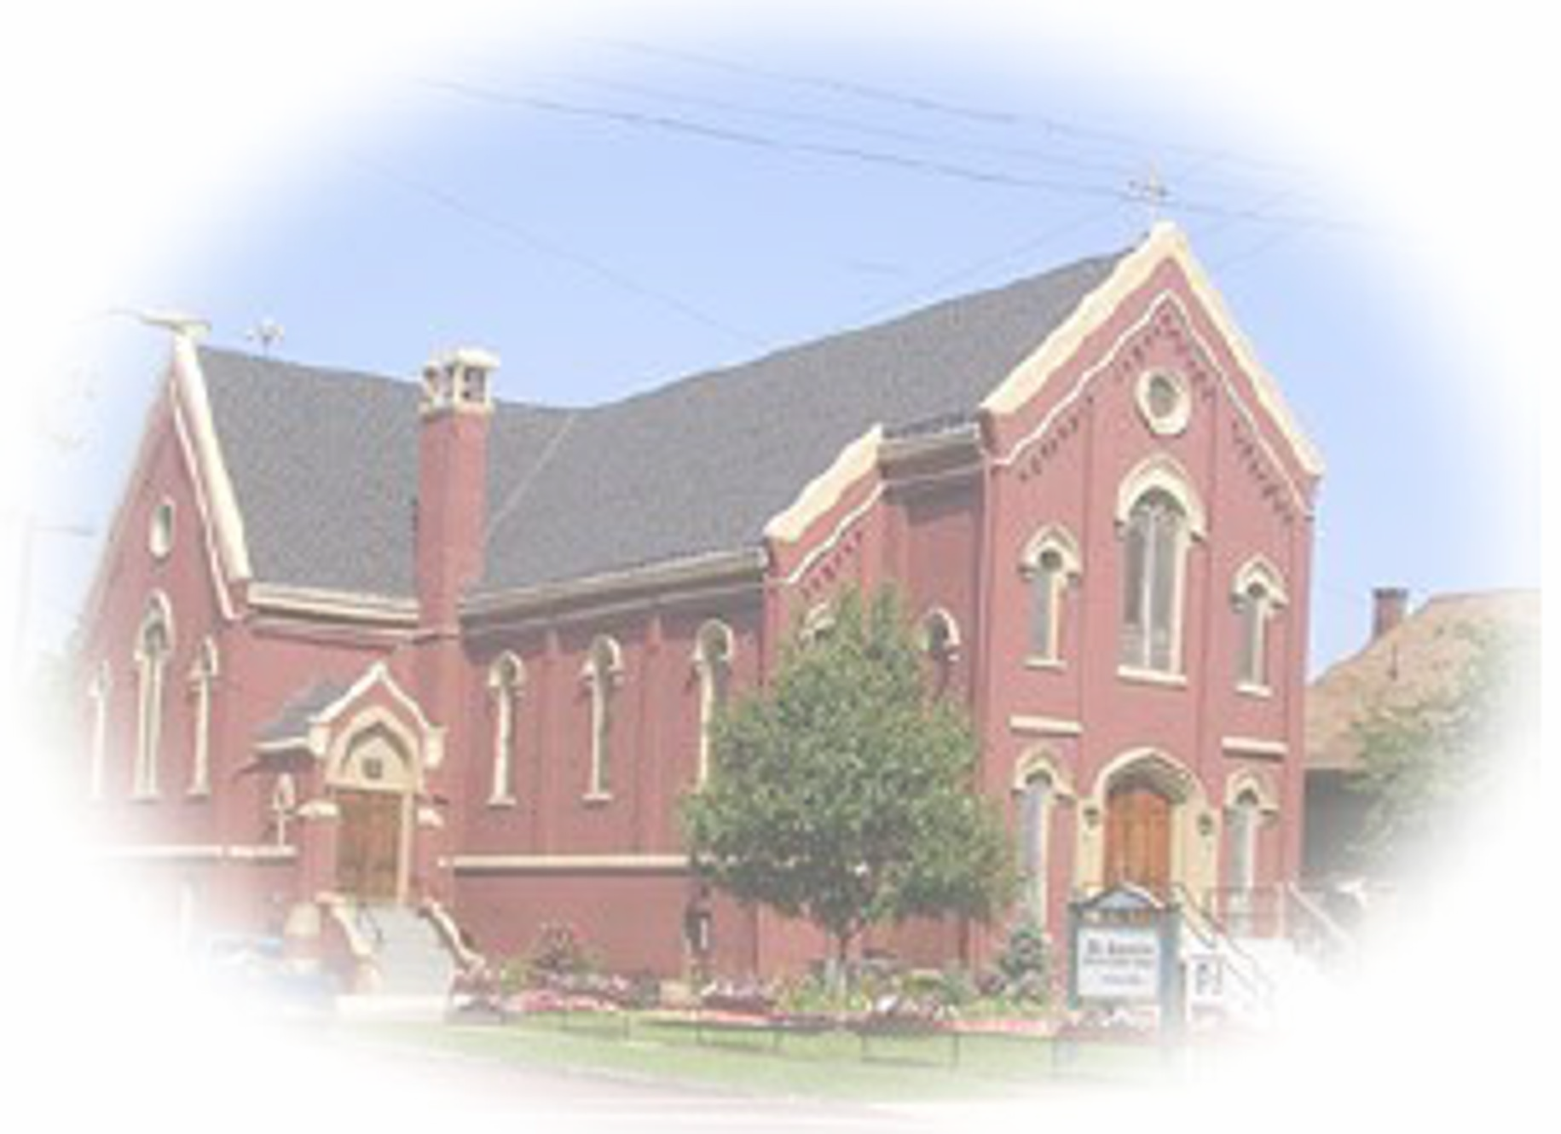

THE CATHOLIC COMMUNITY OF ST. AUGUSTINE

A Samaritan Church with a Missionary Heart

SUNDAY, MAY 8, 2022

Fourth Sunday of Easter

Parish Registration – Welcome new members! Please register by calling the parish office. Parishioners who are moving are asked to contact the office to update their information  Baptism – Baptisms may be scheduled at any time. Please call the parish office to make baptismal arrangements. | Funerals – Please call the parish office to schedule funerals prior to publishing any information.  Matrimony – Call the parish office to meet with a priest. Diocesan regulations require a minimum of 6 months preparation time. | Care of the Sick – Notify the parish office of those who are hospitalized or homebound. Arrangements can be made for pastoral visits, the Sacrament of the Anointing or the Sick. We can also bring Holy Communion to the homebound.

2486 West 14th Street
Cleveland, Ohio 44113

(216) 781-5530
(216) 781-1124 Fax

Website: www.StAugustineCleveland. org

Parish Office Hours:
Monday thru Friday: 9 AM to 5 PM
Saturday: 9 AM to 4 PM
Sunday: 9 AM to 2 PM

Mass Schedule:
Monday thru Friday: 5:30 PM
(Civic holidays at 10 AM)

Saturday: 4:15 PM*
Sunday: 8:30 AM* and 11 AM*
*Interpreted for the Deaf
Confession:
Saturdays from 3:30 PM – 4 PM or by appointment

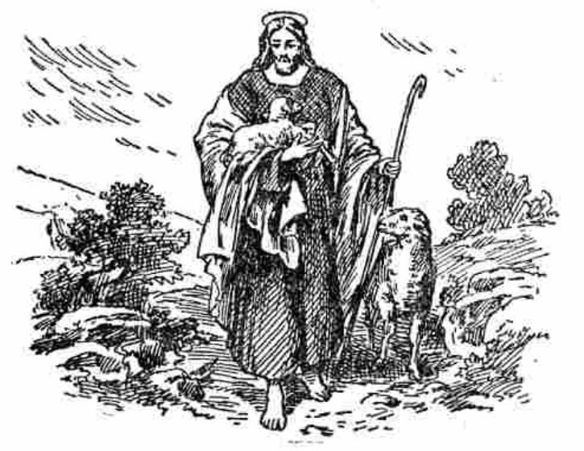
Staff and Ministry Directory
For all Parish emails, add @StAugustineCleveland.org

Administrator: Rev. William O’Donnell, C.PP.S, email: WODonnell Deaf Ministry: email: DeafMinistry
Parochial Vicar: Rev. Ben Jimenez, SJ, email: BJimenez Blind Ministry: email: BlindMinistry
Permanent Deacon: Deacon Chris DePenti Mental Health Ministry: MentalHealth
Parish Administrator: Bob Duda, email: BDuda Outreach Ministry: email: Outreach
Finance Manager: Aldo Fierro, email: AFierro Augustine Rainbow Camp: email: ARC
Office Manager: Doris Everetts, email: DEveretts Signing Choir: email: SigningChoir
Office Support: Kimberly Ambro, email: KAmbro General Information: email: Info
Director of Rainbow Camp and Volunteers: Jessica Neuhart, email: JNeuhart
Religious Education: Kathleen Ulintz, email: PSR

Fourth Sunday of Easter
Every Sunday Jesus draws us here, as a shepherd draws his flock. “My sheep hear my voice,” he says in today’s Gospel, “and they follow me.” Jesus is the Good Shepherd. He feeds his flock, with his own Body and Blood. He loves his flock, suffering and dying for us. He provides for his flock by sending us the Holy Spirit. At home in the comforting embrace of our Good Shepherd, we join together today in thanks and praise.
Mass Intentions for the Week

Saturday, May 7th- 4:15 PM † Gertrude and Henry
Fr. Ben Jimenez, SJ Senyak
Sunday, May 8th- 8:30 AM † Sr. Marietta Starrie, CSJ
Fr. Bill O’Donnell
Sunday, May 8th– 11 AM † Loretta Dulik
Fr. Joe McNulty
Monday, May 9th- 5:30 PM † Kim Plaso
Tuesday, May 10th- 5:30 PM † Larry Gallo
St. Damian de Veuster
Wednesday, May 11th- 5:30 PM † Leonard and Christine Miller
Thursday, May 12th- 5:30 PM † Beatrice Calez
Sts. Nereus and Achilleus
Friday, May 13th- 5:30 PM † Bob and Rosemary Moon
Our Lady of Fatima
Saturday, May 14th- 4:15 PM † Steven Dulik
Fr. Joe McNulty
Sunday, May 15th- 8:30 AM † Gerry Bastaich
Fr. Ben Jimenez, SJ
Sunday, May 15th– 11 AM † Ray Obojski
Fr. Bill O’Donnell, C.PP.S

A prayer for all women on Mother’s Day

Lord, We praise You for each woman in our life: for her faith, her courage, her creativity, her laughter and her leadership. May You bless each one with the joy, grace, wisdom and peace that can only come from You.
In Jesus' Name, Amen

READINGS FOR THE WEEK
Monday: Acts 11:1-18; Ps 42:2-3; 43:3, 4; Jn 10:1-10
Tuesday: Acts 11:19-26; Ps 87:1b-3, 4-5, 6-7; Jn 10:22-30
Wednesday: Acts 12:24 — 13:5a; Ps 67:2-3, 5 -6, 8; Jn 12:44-50
Thursday: Acts 13:13-25; Ps 89:2-3, 21-22, 25, 27; Jn 13:16-20
Friday: Acts 13:26-33; Ps 2:6-7, 8-9, 10-11ab; Jn 14:1-6
Saturday: Acts 1:15-17, 20-26; Ps 113:1-2, 3-4, 5-6, 7-8; Jn 15:9-17
Sunday: Acts 14:21-27; Ps 145:8-9, 10-11, 12- 13; Rv 21:1-5a; Jn 13:31-33a, 34-35

Welcome!
No matter what your present status in the Catholic Church, no matter your personal history, age, income, background, gender, sexual orientation, race, ethnicity or spirituality, or marital situation. No matter your own self-image of holiness or virtue. You are invited, accepted, and respected here at St. Augustine Parish.
Loving God,
For all who feel on the margins,
but who are at the center of your heart,
we ask you to open our hearts.
Help us to become a church and a nation where:
All lives have dignity,
All people are loved
And all are welcome.
Amen

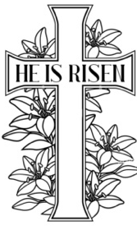

Love without Measure…

Precious Blood Father Alan Hartway is a close friend of mine and classmate. He is a Greek scholar, speaks Spanish and French and is fluent in Hebrew and Aramaic. Given the focus of his academic interest, he spends a great deal of time in the Middle East. During one visit, he tells the story of driving through the countryside and coming across two shepherds whose sheep had become intermingled as they drank from a brook. He watched as the two shepherds spoke with one another. Concluding their conversation, they bid one another farewell and began to walk off in two different directions. As they did so, the one shepherd called out, “Mannah, Mannah” which in Arabic means, “follow me.” At the same time, the other shepherd called out the same words. The sheep lifted their heads, and then divided precisely into two groups, each recognizing the voice of their shepherd.

Jesus uses this shepherding image in today’s gospel to describe his relationship with us. If he is the shepherd, then we must be the ones who recognize his voice and follow him. But what does it mean to recognize the voice of Jesus? There is more than poetry here. Christians believe that at times in our life Christ speaks to us, calls to us, asks us to do something quite specific. What Christ asks us to do can be both dramatic and life changing.

Here is an example: It is the example of the Salwen family, a suburban family from Atlanta. A number of years ago, Kevin, the father, was driving with his fourteen-year-old daughter, Hannah, through the downtown section of the city. They stopped at a traffic light. Hannah, looking out the window, saw a man on the sidewalk holding a sign, “Homeless, please help!” At the same time, she saw a man in a luxurious Mercedes waiting with them at the traffic light. She said to her father, “You know dad, if that man in the Mercedes had a little less nice a car, the man on the sidewalk could have a meal.” Kevin thought for a moment about his daughter’s comment and then said, “You know Hannah, if we had a little less nice a car, that man could have a meal.”

The interchange between father and daughter set the Salwen family on a spiritual journey, a journey that they have recounted in their book, The Power of Half. It is called The Power of Half because after a considerable number of months of family discussion, the Salwens decided that they did not need a big house. They agree to sell their house and give half the proceeds away. Now they had a big house, 6000 square feet, by any measure. The housing market was good in those days. They downsized and were able to give $800,000 to a hunger effort in the African country of Ghana.

Why half? Kevin Salwen would say that half is measurable. So many times, we run into a situation of real need and we say to ourselves, “I should do something.” But ‘something” is vague, and vagueness means that often we end up doing nothing at all. But half is a precise metric. It is a standard that can push us into often. The other advantage of half is

that it is not connected to size. It does not half to be half of your house like it way for the Salwens. It could be half of a

paycheck or half of an evening out or half or half of an unexpected gift. What was important for the Salwens was their conclusion that Christ was asking them to do something. By doing it, they were indicating that they belonged to the good shepherd.

Now, I share this example with you, not because I am recommending that you give half of something away – although if you decide to do that it could be wonderful. I only want to offer a concrete example of someone who heard the voice of Christ speaking in the circumstances of their own life and chose to follow it. If we have a real relationship with Jesus, we should not be surprised if occasionally Christ asks us to do something. It could be giving money to the poor. It might be reconciling with an enemy. It might be spending more time with the family, seeking out counseling, or entering a specific career.

Christ can speak to us in many ways, But if we call ourselves Christians and we never hear Christ asking us to do anything, something is wrong. And it is unlikely that we hear nothing because Christ is not speaking. It is much more likely that we are not listening. Not listening or being attentive is a serious concern for all of us because if Christ is truly our shepherd, he is calling. So, the important question for each of us here today is what is Christ calling me to do? What is Christ asking me to do? It is a question that is essential to our relationship, because we cannot follow him if we do not recognize his voice.
.

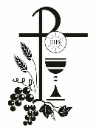
First Holy Communion
First Holy Communion for our parish will be celebrated next Sunday, May 15th during the 11 AM Mass with a reception to follow in Walsh Hall. All are welcomed to attend the Mass and reception.
We congratulate the 11 students from Incarnate Word Academy who made their First Holy Communion at St. Augustine on Saturday, May 7th.
Welcome! You are invited to a complimentary parish breakfast on Sunday, May 22nd from 9:15 AM until 1 PM in Walsh Hall (basement of school building).
We hope that you will be able to join us for food and fellowship. This is a great opportunity to see longtime friends and meet new members of our parish family.
Augustine Rainbow Camp
With summer quickly approaching, we are excited to begin staffing for the 2022 camp season! We are looking for hardworking, responsible, and fun-loving individuals, ages 16 and older, to help us create an outstanding experience for our campers this summer! If that sounds like you, or someone you know, please contact ARC@StAugustineCleveland.org to receive an application. Working at camp is a great opportunity to have fun while building leadership skills, adding quality work experience to a resume, and to give back to the community!

Camper applications are now available online at www.StAugsutineCleveland.org. If you do not have access or need help completing the online application, please contact the parish office at (216) 781-5530.

A wish list of items needed for this camping season can be found online at www.StAugustineCleveland.org/augustine-rainbow-camp or on in information table located at each entrance.

We look forward to hearing from you!

The Great Month (August)
We are looking for volunteers to participate in the planning of the annual Great Month. If you are interested in participating in the planning and execution of the event, please contact Bob Duda at (216) 781-5530 ext. 31 or by email at BDuda@StAugsutineCleveland.org.

Thank you for supporting this annual parish celebration.
“Whatever happens, don’t let go!”
There is a wonderful scene towards the end of the movie, Titanic. As the ship is preparing to take its final plunge into the cold waters of the Atlantic, Jack Dawson and Rose are hanging straight onto the edge of the ship. Jack turns to Rose and tells her: "Don't let go. Whatever happens, don't let go." There is something profound in knowing that there is someone who wants us to hold on -- no matter how difficult the situation. As children, we hold on to our parents for guidance and protection. When we are adults, we hope to find a spouse or close friend who will hold us when we are hurt and carry us when we stumble. In today's Gospel, we hear the profound revelation from Jesus that God intends to "hold us" through every storm and every difficulty of life.

Jesus, as our Good Shepherd, offers us double protection. He assures us that we are in his hands, and nothing will ever take us from him. He further assures us that we are safe in the sheepfold which is the local parish.

Full-Time Parish Receptionist
We are seeking to hire a full-time Monday thru Friday Parish Receptionist. The ideal candidate would enjoy working with the public and have office experience . For more information, please contact the parish office at (216) 781-5530 or BDuda@StAugustineCleveland.org.

Via Lucis
Stations of the Resurrection
Fr. Joe McNulty will lead us in Via Lucis, also known as the Stations of the Resurrection, each Friday during the Easter Season.
The Via Lucis is a form of devotion, encouraging meditation upon the Resurrection of Jesus Christ and some of the Resurrection appearances and other episodes recorded in the New Testament
Please note that Stations will begin at 5:00 PM prior to daily mass.

Mother Teresa’s Good Shepherd Prayer
During her visit to the United Nations several years ago, Mother Theresa was approached by a diplomat who said, “I am not a Catholic, Mother. But I want to know how should I pray.” The frail little nun took his burly hands in hers and spread out five of his fingers on one hand. “When you pray,” she said, “Think about the many blessings you have received; then, at the end of the day, count out on each finger the words spoken to you by Jesus: You.. did.. this.. for.. me.” The diplomat left holding up his hand as though it were a trophy and saying: “You did this for me.” In this simple prayer, Mother Theresa made the Resurrection seem real. What she meant was that the love and peace of the Good Shepherd is present to us in the many moments of compassion that bless our lives: in kind words, in the listening ear, in generous actions. Jesus is also present in the blessings we extend to others.

The Good Shepherd of today’s Gospel guides us every day in our journey to eternal life. Even as we allow the Good Shepherd to guide us, we need to remember that everyone who is entrusted with the care of others is a shepherd. Hence, pastors, parents, teachers, doctors, nurses, government officials- we are all shepherds. We become good shepherds by loving those entrusted to us, praying for them, spending our time and talents for their welfare, and guarding them from physical and spiritual dangers. Parents must be especially careful of their duties, thus giving their children good example through the way they live their Christian lives.

St. Augustine Signing Choir
Signing Choir practice will continue this Wednesday, May 11th at 6:30 PM. Anyone interested in joining the choir, with or without signing experience, is invited to attend their next practice in Walsh Hal. More information can be obtained by calling the parish office at (216) 781-5530 or by email at SigningChoir@StAugsutineCleveland.org.

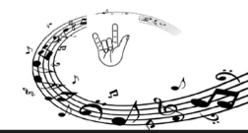
Spring Concert
The St. Augustine Signing Choir proudly presents a Concert of Love Through Song and Sign.

You are invited to join us for an afternoon of music in American Sign Language on Saturday, May 14, 2022 at 1 PM in Church. Following the concert there will be a light reception in Walsh Hall.

Attendees are asked to bring sports or art supplies for Augustine Rainbow Camp.
Finding the Missing Words
"My sheep hear my voice; I know them, and they follow me. I give them eternal life and, and they shall never perish." John 10: 27-30

She struggled to rally a smile as she entered his hospital room. Paul, her husband of 35 years, had suffered a massive stroke. She struggled to rally a smile. "Hi, honey," she said. Paul looked at her helplessly. His face was frozen in a distorted scowl, his mouth slouched to the right, his lip curled. He tried to answer. But all he could sputter was "Mem." Of course, she had no idea what he was trying to say. When she didn't respond, he brought down his fist on the bed railing, repeating, "Mem, mem, mem." When she tried to comfort him, he pushed away. He struggled to speak, but all he could manage was a little sound - whgggggggg - as if he were blowing out a candle. His frustration became anger, before he finally fell back on his pillow, defeated." Mem, mem, mem."

"I wish I could understand you," she said, more to herself than to him. “Mem, mem, mem," he cried. "Mem, mem, mem" - the first words of the new language that they would learn together. Once home, as she helped him recover, he had to relearn language - and she had to learn a new one. Over time, Paul was able to speak words other than "Mem" - and she was able to understand the different meanings of "Mem" on different days, at different times, in different sets of circumstances. Paul gradually recovered his speech, though his days are still riddled with aphasia. But thanks to the plasticity of the brain, the power of human will, and plain hard work, she hears him and understands what he is trying to say.

Six years after she walked into that hospital room, she says, "life is different, but sweet, often delving into hilarious charades as he tries to pin a word down . . . So, there are many frustrations, but once again a shared revelry with words. And Paul seems altogether happier than before, living more in the moment, grateful to be alive. "We often remember with a shiver those early days in the hospital, when life felt small as a noose, and I thought it was the end of our long love story. I discovered instead that it was only the beginning of a new chapter." [From One Hundred Names of Love: A Stroke, a Marriage and the Language of Healing by Diane Ackerman.]

Love that perseveres despite the obstacles, love that refuses to yield to discouragement and disappointment, love that puts aside personal need and gain for the sake of the beloved is the "voice" of the Good Shepherd." With compassion, a spouse struggles tracelessly to decipher the love in the gnarled speech of her husband and responds in kind. The "voice" of Christ is heard in the midst of their hard work to reconstruct their life together in hope and joy. Christ the Good Shepherd calls us to listen consciously, deliberately, wisely for his voice in the depths of our hearts; to listen for his voice in the love and joy, the pain and anguish, the cries for mercy and justice of those around us. In our own acts of generosity, love and forgiveness, we echo and give voice to the Risen Christ and the good news of hope and grace that is the Easter miracle.
Pray the Rosary
We invite you to join us every weeknight (Monday thru Friday) at 6 PM in the church as we pray the rosary. If you are unable to join us in person, we encourage you to join us on livestream.
Co-Ed Volleyball League
Plans for our volleyball league are moving forward. Keep an eye out for more information on when an informational meeting will take place.

To register as a player and/or coach, please visit, www.staugustinecleveland.org.
St. Damien de Veuster of Molokai
Feast Day: May 10th
People may be familiar with leprosy from Biblical times, but not so much in the 1800s. However, St. Damien de Veuster of Molokai (January 3, 1840 – April 15, 1889) would eventually shed light on the effects of this devastating disease and allow people to see those afflicted with it with more compassion and love.

Born Joseph de Veuster in Tremelo, Belgium, he quit school at 13 so he could work on the family farm. Feeling called for more, however, he entered the Congregation of the Sacred Heart of Jesus and Mary six years later, where he took the name of a fourth-century physician and martyr. His brother, a priest from the same congregation, fell ill and was unable to go to his assigned location. Damien quickly volunteered in his place and found himself on the Hawaiian Islands in 1864. Two months after arriving, he was ordained a priest of Honolulu and assigned to the island of Hawaii.

In 1873, he visited the Hawaiian government’s leper colony on the island of Molokai, where he petitioned to stay permanently to care for their physical, medical, and spiritual needs. After years of working to improve their location and those who lived there, he contracted Hansen’s Disease (Leprosy) and died of its complications. St. Damien was canonized by Pope Benedict XVI on October 11, 2009.
Our Parish School of Religion classes will continue this Monday, May 9th at 5:30 PM.

Our last day of class for the 2021-2022 school year will be on May 16, 2022. Please be sure to register your child for our 2022-2023 school year. For more information please email, PSR@StAugustineCleveland.org.
Inspiration for the Week
Do we hear and follow? Before we can welcome Jesus as the Good Shepherd, we have to hear his voice. God’s voice breaks into the dialogue of our lives in a myriad of ways, but we have to be attentive and receptive in order to hear it. It comes throguht the beauty of creation, the warmth and energy of love, the gift of compassion bother received and given, the sacred in the miracle of life, and the orderly and purposeful design of things and in the truth found in God’s commandments. Once we see the wisdom behind the commandments and teachings God places before us and are attentive to listening for His direction, we can begin to take the necessary steps and follow Him. We are easily misled and there are many convincing “shepherds.” Only one is Good. It is only the Good Shepherd who can lead us away from the evils that can hurt us and bring us to the good. We may not always like where God asks us to go, and it may not be the path otheres prefer to take. But we have to follow it because we trust that our kind Shepherd will keep us safe.
Happy Mother’s Day!
In recognition of the role women play in our lives, we invite all women to a special blessing this Mother’s Day weekend. We also invite you to take a flower with you as you leave church. May the Good Shepherd continue to bless you as you fulfill your earthly vocation by accompanying us on our journey to our Heavenly reward.

Cursillistas will gather for Ultreya on Saturday, May 14th at 10 AM in Walsh Hall. Cursillistas are invited to gather, pray, and share personal stories about living a life in God's Grace on the second Saturday of every month.
“I Only Know Them by Name”
Once a particular census taker went to the home of a rather poor family in the mountains of West Virginia to gather information. He asked the mother how many dependents she had. She began, "Well, there is Rosie, and Billy, and Lewella, Susie, Harry, and Jeffrey. There's Johnny, and Harvey, and our dog, Willie." It was then that the census taker interrupted her aid said: "No, ma'am, that's not necessary. I only need the humans." "Ah," she said. "Well, there is Rosie, and Billy, and Lewella, Susie, Harry, and Jeffrey, Johnny, and Harvey, and...." But there once again, the census taker interrupted her. Slightly exasperated, he said, "No, ma'am, you don't seem to understand. I don't need their names, I just need the numbers." To which the old woman replied, "But I don't know them by numbers. I only know them by name."

In today’s gospel Jesus the good shepherd says that he knows his sheep by name. Just as the Palestinian shepherds knew each sheep of their flock by name, and the sheep knew their shepherd and his voice, even so Jesus knows each one of us, our needs, our merits and our faults. Of course, the knowledge talked of here is not mere intellectual knowing but knowledge that comes from love and leads to care and concern for the other. He loves us as we are, with all our limitations, and he expects us to receive and return his love by keeping his words. He speaks to us at every Mass, through the Bible, through our pastors, through our parents, family and friends and through the events of our lives. "God whispers to us in our pleasures, he speaks to us in our consciences, and he SHOUTS to us in our pain!" (C.S. Lewis).

We live stream the Saturday 4:15 PM Mass, the 11 AM Mass on Sunday, and the weekday Rosary on the parish website, Facebook Page and YouTube Channel. A live audio feed will be available for the Saturday 4:15 PM Mass the 11 AM Sunday Mass, and the praying of the Rosary. To access the audio feed, please call (216) 270-6331prior to mass/rosary and enter code 2020 when prompted.

Parish Pastoral Council
Parish Pastoral Council will meet on Monday, May 16th at 7 PM in the Deaf Center.
St. Augustine Food Pantry
Our Community Cupboard Food Pantry is making great progress and already meeting the needs of those who come to us seeking assistance. An official opening date with regular hours will be polished soon.

A sincere thank you to Deacon Chris and the many volunteers who continue to work in the St. Augustine Food Pantry. The Pantry is located on the first floor of our former school building and currently accepts non-perishable items.

For more information, please contact the parish office at OutreachMinistry@StAugustineCleveland.org or by calling (216) 781-5530.
Family Perspective
Today the Gospel of John teaches us that Jesus said "My sheep hear my voice; I know them, and they follow me..." When our mother or father calls our name we can hear them in a crowd. We can tell the difference between our friends’ voices too. The goal is for us to know Jesus as the shepherd and that in our prayers we hear HIM speaking to our hearts and know what He is asking us to do. We pray that our ears be open to the Lord and what he might be calling us to do in this day.
On the Lighter Side
Daughter: “Mom, what’s it like to have the greatest daughter in the world?”
Mom: “I don’t know dear; you’d have to ask Grandma.” ☺

Sunday Thought
In this weekend’s Gospel, Jesus calls Himself the shepherd who is constantly caring for His sheep. Because Jesus is the model for all our activities, His identification with shepherding invites us to imitate Him. We can do this in numerous ways. The power of good example is the simplest and most accessible way we can respond to this calling to shepherd. Our families and friends often look to us for direction. The goodness of our actions can speak volumes to them without our speaking a word. The ministry of shepherding may also take on a more formal fashion. The care that we extend to others, especially the sick, the poor, the elderly, requires our attention. While we will not be expected to replace the many social agencies, we have at hand to help, in many of these situations as followers of the Good Shepherd, we too must see what part we might be able to play to alleviate the sufferings of others. Shepherding may also take on the manner of using our God-given talents and gifts in roles of service at the Liturgy. The parish is always in need of assistance from others as ushers, lectors, and Eucharistic ministers. The avenue for acting as Jesus’ good shepherds is wide. All that is really needed is our willingness to travel it.

Stewardship of Treasure
We are deeply grateful for your generosity in your weekly contribution to St. Augustine Parish. Your kindness and support enable us to provide for the needs of our parish and community. The collection for the weekend of May 1, 2022, was $1,745.00. Thank You!
St. Augustine Seniors
The St. Augustine Seniors will gather for their May Crowning on Thursday, May 12, 2022 at 12 Noon in Walsh Hall.
This Week’s Events of the Parish
Monday: Mass: 5:30 PM (Church)
Parish School of Religion: 5:30 PM (School Building)
Lincoln Heights Block Club: 6 PM (Deaf Center)
Rosary: 6 PM (Church)
AA Meeting: 7:30 PM (Mylott Hall)
Tuesday: AA Meeting: 9:30 AM (Walsh Hall)
Buckeye Deaf Seniors: 10 AM (CCDC)
Mass: 5:30 PM (Church)
Rosary: 6 PM (Church)
Signing Hands: 6:15 PM (Walsh Hall)
Sign Class: 7 PM (Deaf Center)
AA Meeting: 7:30 PM (Mylott Hall)
Wednesday: LINKS: 3 PM
Mass: 5:30 PM (Church)
Rosary: 6 PM (Church)
AA Meeting: 6 PM (Mylott Hall)
Signing Choir Practice: 6:30 PM (Walsh)
Thursday: St. Augustine Seniors: 12 Noon (Walsh)
Mass: 5:30 PM (Church)
Rosary: 6 PM (Church)
Boy Scouts: 6:30 PM (Second Floor)
AA Meeting: 7 PM (Mylott Hall)
Friday: LINKS: 3 PM
Stations of the Resurrection: 5 PM (Church)
Mass: 5:30 PM (Church)
Rosary: 6 PM (Church)
AA Meeting: 7:30 PM (Mylott Hall)
Saturday: Signing Choir Concert: 1 PM (Church)
Mass: 4:15 PM (Church)
Sunday: Mass: 8:30 AM and 11 AM (Church)
Parish First Holy Communion: 11 AM Mass

H: Homilist
May 7th and 8th
 | Saturday  4:15 PM | Sunday  8:30 AM | Sunday  11 AM
Priest  Deacon | Fr. Ben Jimenez, SJ (H) | Fr. Bill O’Donnell, C.PP.S (H) | Fr. Joe McNulty (H)
Lectors | Michelle Rivera | Debbie Sollars | Jean Mendis  Rosanne Barnhart
Extraordinary Ministers of the Blessed Sacrament | Theresa Ortiz |  | Karen Halupnik
May 14th and 15th
 | Saturday  4:15 PM | Sunday  8:30 AM | Sunday  11 AM
Priest  Deacon | Fr. Joe McNulty (H)  Deacon Chris DePenti | Fr. Ben Jimenez, SJ (H) | Fr. Bill O’Donnell, C.PP.S (H)  Deacon Chris DePenti
Lectors | David Dylyn | Peggy Gerovac | Tom Smith  Priscilla Treska
Extraordinary Ministers of  the Blessed Sacrament | Helen Bencic | Maria Rivera

Say It in Sign
Our sign language class for beginners will conclude this week on Tuesday from 7 PM to 8 PM in the Deaf Center. If you were unable to previously register for this session, please know that we will be offering another session in the fall. To pre-register or for more information, please contact Bob Duda at (216) 781-5530 or at BDuda@StAugustineCleveland.org.

May I see your Driver’s License?”
Everyone, it seems, is interested in my numbers. I go to the grocery store to buy some groceries. After the checkout woman rings up my bill, I pull out my checkbook and write out the check. She takes it from me. She looks at the information. Numbers tell her where I live. Numbers tell her how to reach me on the telephone. "Is this information correct?" she asks.” Yes, it is," I reply. "May I see your driver's license?" she asks. She looks at my driver's license and writes some more numbers on my check. Finally, I am approved. The numbers are all there. I can eat for another week. One could wish it were a bit more human and personal. So, the IRS knows me by my tax number. My state knows me by my driver's license number. My bank knows me by my bank account number. My employer knows me by my social security number. On and on it goes for you, for me, for everybody. Everybody knows my numbers. I am not sure that anyone knows me! The numbers game that is played in our culture is one symptom of loneliness and alienation that surrounds us today. "All the lonely people, where do they all come from?" That is a line from an early song by the Beatles. Loneliness. Isolation. Alienation. These are the realities of contemporary civilized life.

"I am the good shepherd." These are Jesus' words in our reading from John's gospel for today. "I am the good shepherd; I know my own and my own know me ..." Isn’t it wonderful to know that Jesus knows us personally and loves us?

☺ 10 Lessons From My Mother! ☺
1. My mother taught me RELIGION: "You'd better pray that it will come out of the carpet."
2. My mother taught me TIME TRAVEL: "If you don't straighten up, I'm going to knock you into the middle of next week!"
3. My mother taught me FORESIGHT: "Make sure you wear clean underwear, in case you're in an accident."
4. My mother taught me IRONY: "Keep crying, and I'll give you something to cry about."
5. My mother taught me about CONTORTIONISM: "Will you look at that dirt on the back of your neck!"
6. My mother taught me about WEATHER: "This room of yours looks as if a tornado went through it."
7. My mother taught me about ENVY: "There are millions of less fortunate children in this world who don't have wonderful parents like you do."
8. My mother taught me HUMOUR: "When that lawn mower cuts off your toes, don't come running to me."
9. My mother taught me WISDOM: "When you get to be my age, you'll understand."
10. My mother taught me about JUSTICE: "One day you'll have kids, and I hope they turn out just like you"

Welcome, Jessica!
We are happy to announce that Jessica Neuhart has joined us as our new Director of Augustine Rainbow Camp and Volunteers. Jessica is a life-long parishioner and has been an integral part of Augustine Rainbow Camp for many years. She is a member of our music ministry and performs with our signing choir. We wish her well as she continues to share her talents with us in this new role.

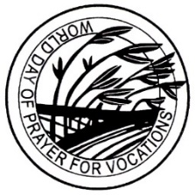
World Day of Prayer for Vocations
The church is badly in need of good shepherds. Hence today is a special day to pray for vocations. But the term vocation simply means calling. We all are called to a particular way of life according to the plan of God. Hence, we pray for vocations not only to the priesthood, diaconate and the consecrated life, but also for the different lay vocations to the married life, to single life, to missionary calling, etc., so that we may have more holy and Spirit-filled shepherds to lead, feed and protect the Catholic community. Christian thinking on vocation has been summarized in one profound saying: “All are priests, some are priests, but only one is the Priest.”

Christ Jesus is the Priest in the full sense because he is the one mediator between God and humanity who offered Himself as a unique sacrifice on the cross. The universal priesthood of all believers, the sharing of all the baptized in the priesthood of Christ, has received special emphasis since Vatican II. Those who are called to make a lifelong commitment to serve as ordained ministers share the ministerial priesthood of Jesus. On this World Day of Prayer for Vocations, we are asked to encourage and pray for our young men to respond to God’s call to serve His Church in the ministerial priesthood.

You and I are called to be Good Shepherds
When the emperor Alexander the Great was crossing the Makran Desert on his way to Persia, his army ran out of water. The soldiers were dying of thirst as they advanced under the burning sun. A couple of Alexander's lieutenants managed to capture some water from a passing caravan. They brought some to him in a helmet. He asked, "Is there enough for both me and my men?" "Only you, sir," they replied. Alexander then lifted up the helmet as the soldiers watched. Instead of drinking, he tipped it over and poured the water on the ground. The men let up a great shout of admiration. They knew their general would not allow them to suffer anything he was unwilling to suffer himself.

Are you a good shepherd? Everyone who is entrusted with the care of others is a shepherd. Hence pastors, parents, teachers, doctors, nurses, government officials and politicians, etc. are all shepherds. Since shepherding a diocese, a parish, a civil community or a family is very demanding, dedication, commitment, sacrifice and vigilance are needed every day on the part of the shepherds. We become good shepherds by loving those entrusted to us, praying for them, spending our time and talents for their welfare, and guarding them from physical and spiritual dangers.

Stewardship Reflection
The disciples were filled with joy and the Holy Spirit.”
(ACTS 13:52)

The disciples heard Our Lord’s call and were able to spread the Gospel message with strength and vitality. We, too, can experience that same joy if we make room for the Holy Spirit to fill our hearts. When we use our gifts in the way that God intends, He fills us with supernatural joy. A joy that others notice and are attracted to!

A Good Shepherd- Sergeant’s Story
There was once a sergeant in the Marines who was the senior enlisted man in his platoon. One day his outfit was ambushed and pinned down by enemy fire. The lieutenant in command was badly wounded as were many of the men. The sergeant took over and extricated the men from the trap, though he himself was wounded twice. He carried out the wounded commanding officer by himself. Miraculously every man in the platoon survived, even the wounded lieutenant. Later the men said that if it were not for the incredible bravery of the sergeant, they all would have been killed. He was recommended for the Medal of Honor but received the DFC. He never wore the medal, however, because he said the lives of his men were more important than any medal. Later when he had children of his own, he loved them almost like a mother. His wife said that during the war he had learned how to be tender.

Jesus the good shepherd is willing to make any sacrifice for us his sheep. Just as the shepherds of ancient days protected their sheep from wild animals and thieves by risking their own lives, so Jesus died in expiation for the sins of all people. In the final part of this gospel Jesus invites those who are touched and saved by the love of the Shepherd, to shepherd and care for others. "There are other sheep that are not of this fold and these I have to lead as well." Though he cares for his own, he does not discriminate and ultimately dies because he cares for all peoples.

